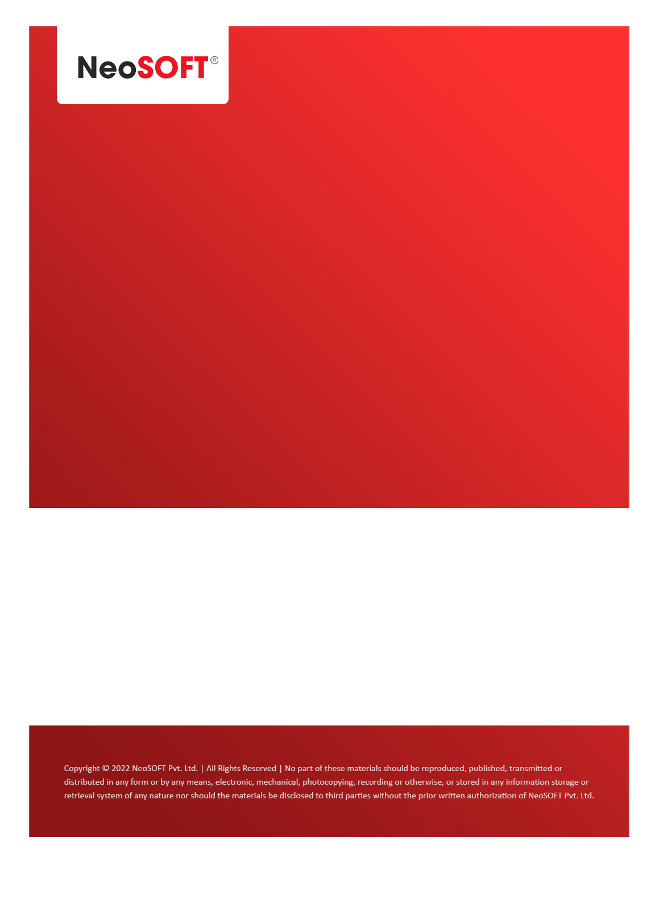`

**Eltizam**

**MOM – RGM 4**

Eltizam

Client Name

NeoSOFT is a SEI-CMMI Level-5 Global IT Consulting & Software Solutions Provider

**March 27**, 2023

|  |  |
| --- | --- |
| **Meeting Date, Time, and Attendee Details** | |
| **Date** | 27th March 2023 |
| **Venue** | MS Teams |
| **Time** | 04.00 PM – 05.00 PM IST |
| **Meeting Type** | Wireframes demo, queries discussion |
| **Internal Attendees** | * YallaReddy * Akshata Shinde |
| **Client Attendees** | * Karuna Pawar |
| **MOM Prepared By** | * Akshata Shinde |

|  |  |
| --- | --- |
| **Details of Meeting** | |
| **Sr. No.** | **Description** |
| 1 | In today’s call, Akshata shared wireframes with Karuna by screen wise and discussed, reviewed and noted down changes to be done. |
| 2 | Karuna have list of questions from Akshata which we need to share with business team. |
| 3 | Akshata will share functionality document for approval master flow which yet to wireframe. |
| 4 | Eltizam, Client is expecting us to share some real estate related developed projects inforation from NeoSOFT & Poonam needs to share portals. |
| 5 | We will regroup tomorrow again on status, queries discussions. |

|  |  |  |  |  |  |
| --- | --- | --- | --- | --- | --- |
| **Actionable** | | | | | |
| **Sr. No.** | **Action Item** | **Assigned to** | **Assigned Date** | **Expected Completion Date** | **Status** |
|  |  |  |  |  |  |
|  |  |  |  |  |  |
|  |  |  |  |  |  |